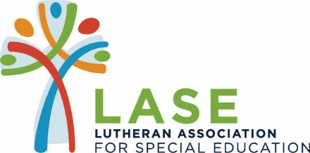

36th ANNUAL GOLF TOURNAMENT
In Partnership with Foam Supplies, Inc.
June 18, 2018 at Sunset Country Club
Sponsorship Form

EAGLE SPONSOR _____ $2,400 - Four Complimentary Golfers with Mega Ticket*,
Lunch, Cocktails & Dinner, Two Hole Signs & Program Half Page Ad

BIRDIE SPONSOR ____ $1,200 – Two Complimentary Golfers with
Mega Ticket*, Lunch, Cocktails & Dinner, One Hole Sign &
Program Quarter Page Ad

PAR SPONSOR _____ $600 – One Complimentary Golfer with Mega
Ticket*, Lunch, cocktails & Dinner, One Hole Sign & Business Card Ad

BEVERAGE CART SPONSOR _____ $300 - Two Cart Signs & Program Business Card Ad

LORI’S LEGACY SPONSOR _____ $1,000 – Two Dinner Tickets and Program Recognition

FRIEND OF LASE SPONSOR _____ $100 – Program Recognition

* Mega Ticket entitles each player to 2 mulligans and 1 raffle opportunity

______________________________ ______________________________
Signature/Date Signature/Date

Hole Sign to Read: _________________________________________________

Contact Information: ___________________________________________________
(Print name, phone number and email address)
Please email your company logo in JPEG or CMYK format.

Payment due by 6/1/18

Thanks for helping us Tee it up for the Children of LASE!

