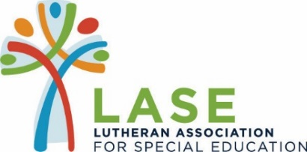
37th ANNUAL GOLF TOURNAMENT
In Partnership with Foam Supplies, Inc.
June 24, 2019 at Sunset Country Club
Sponsorship Form

MASTERS SPONSOR _____ $5,000 – Two Foursomes, Lunch, Cocktails &
Hors D’oeuvres Dinner, Four Hole Signs & Back Cover
Ad in Evening Program Booklet

EAGLE SPONSOR __ $2,500 - Four Complimentary Golfers, Lunch, Cocktails & Hors D’oeuvres
Dinner, Two Hole Signs & Half Page Ad in Evening Program Booklet

BIRDIE SPONSOR _____ $1,250 – Two Complimentary Golfers, Lunch, Cocktails & Hors D’oeuvres Dinner,
One Hole Sign & Program Quarter Page Ad in Evening Program Booklet

PAR SPONSOR _____ $600 – One Complimentary Golfer, Lunch, Cocktails & Dinner, One Hole Sign &
Business Card Ad in Evening Program Booklet

LORI’S LEGACY SPONSOR ___ $1,000 – Two Dinner Tickets and Recognition in Evening Program Booklet

FRIEND OF LASE SPONSOR _____ $100 – Recognition in Evening Program Booklet

______________________________ ______________________________
Signature/Date Signature/Date

Hole Sign to Read: _________________________________________________

Contact Information: ________________________________________________________________________
(Print name, phone number and email address)

Please email your company logo in PNG or JPG format. Deadline is 5/1/19
Thanks for helping us Tee it up for the Children of LASE!

