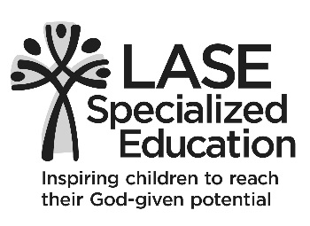
2020 Herald the Holidays
November 7, 2020
Program Ad Application

Lutheran Association for Special Education (LASE) has a heart for helping children who learn differently reach their God-given potential. LASE is a non-profit 501c organization that partners with parents and schools to provide solution-focused special education expertise in a Christian setting. LASE strives to teach the whole child utilizing individualized
and specialized learning solutions.

Herald the Holidays hosts 300+ LASE supporters and guests each year. They are customers who frequent businesses in your community. LASE would appreciate the opportunity to promote your business in our program booklet or share an encouraging message with our students. If you’ve advertised with us previously, we thank you and ask that you
kindly repeat your support for our LASE kids again this year. Your ad partnership
Your donation may be tax deductible. Please keep a copy of this form for your records. LASE is a 501 (c) tax-exempt organization.
with us helps fund opportunities that positively impact the lives of our students with special education needs.

Name: ________________________________________________________
Please print name exactly as you would like it to appear in the program.
Address: _________________________________________________________
City: _________________________ State ______________ Zip ____________________
Phone: __________________________ Email: ____________________________________
Message to Read: ______________________________________________________________
_______________________________________________________________
Advertisement Options: All ads (other than cover pages) are black and white/landscape ___ $300 Full page - color (5 x 7.5 inches) Inside cover or inside back cover
___ $200 Full page - black/white (5 x 7.5 inches)
____$100 Half page – black/white (5 x 3.59 inches)
____$50 Quarter page/Business Card or personal message - black/white (4 x 2 inches)
Please email typeset image (jpg or png) to karen.scuito@lutheranspecialed.org. Deadline is October 20, 2020 Mail check payable to LASE at 3558 S. Jefferson Avenue, St. Louis, MO 63118 Thank you for your continued support for the children of LASE!

